ITRI616 Project
C_lines Game with Machine Learning Agent
BSc in Computer Science & Information Technology Honours 2026

North-West University
Vanderbijlpark Campus
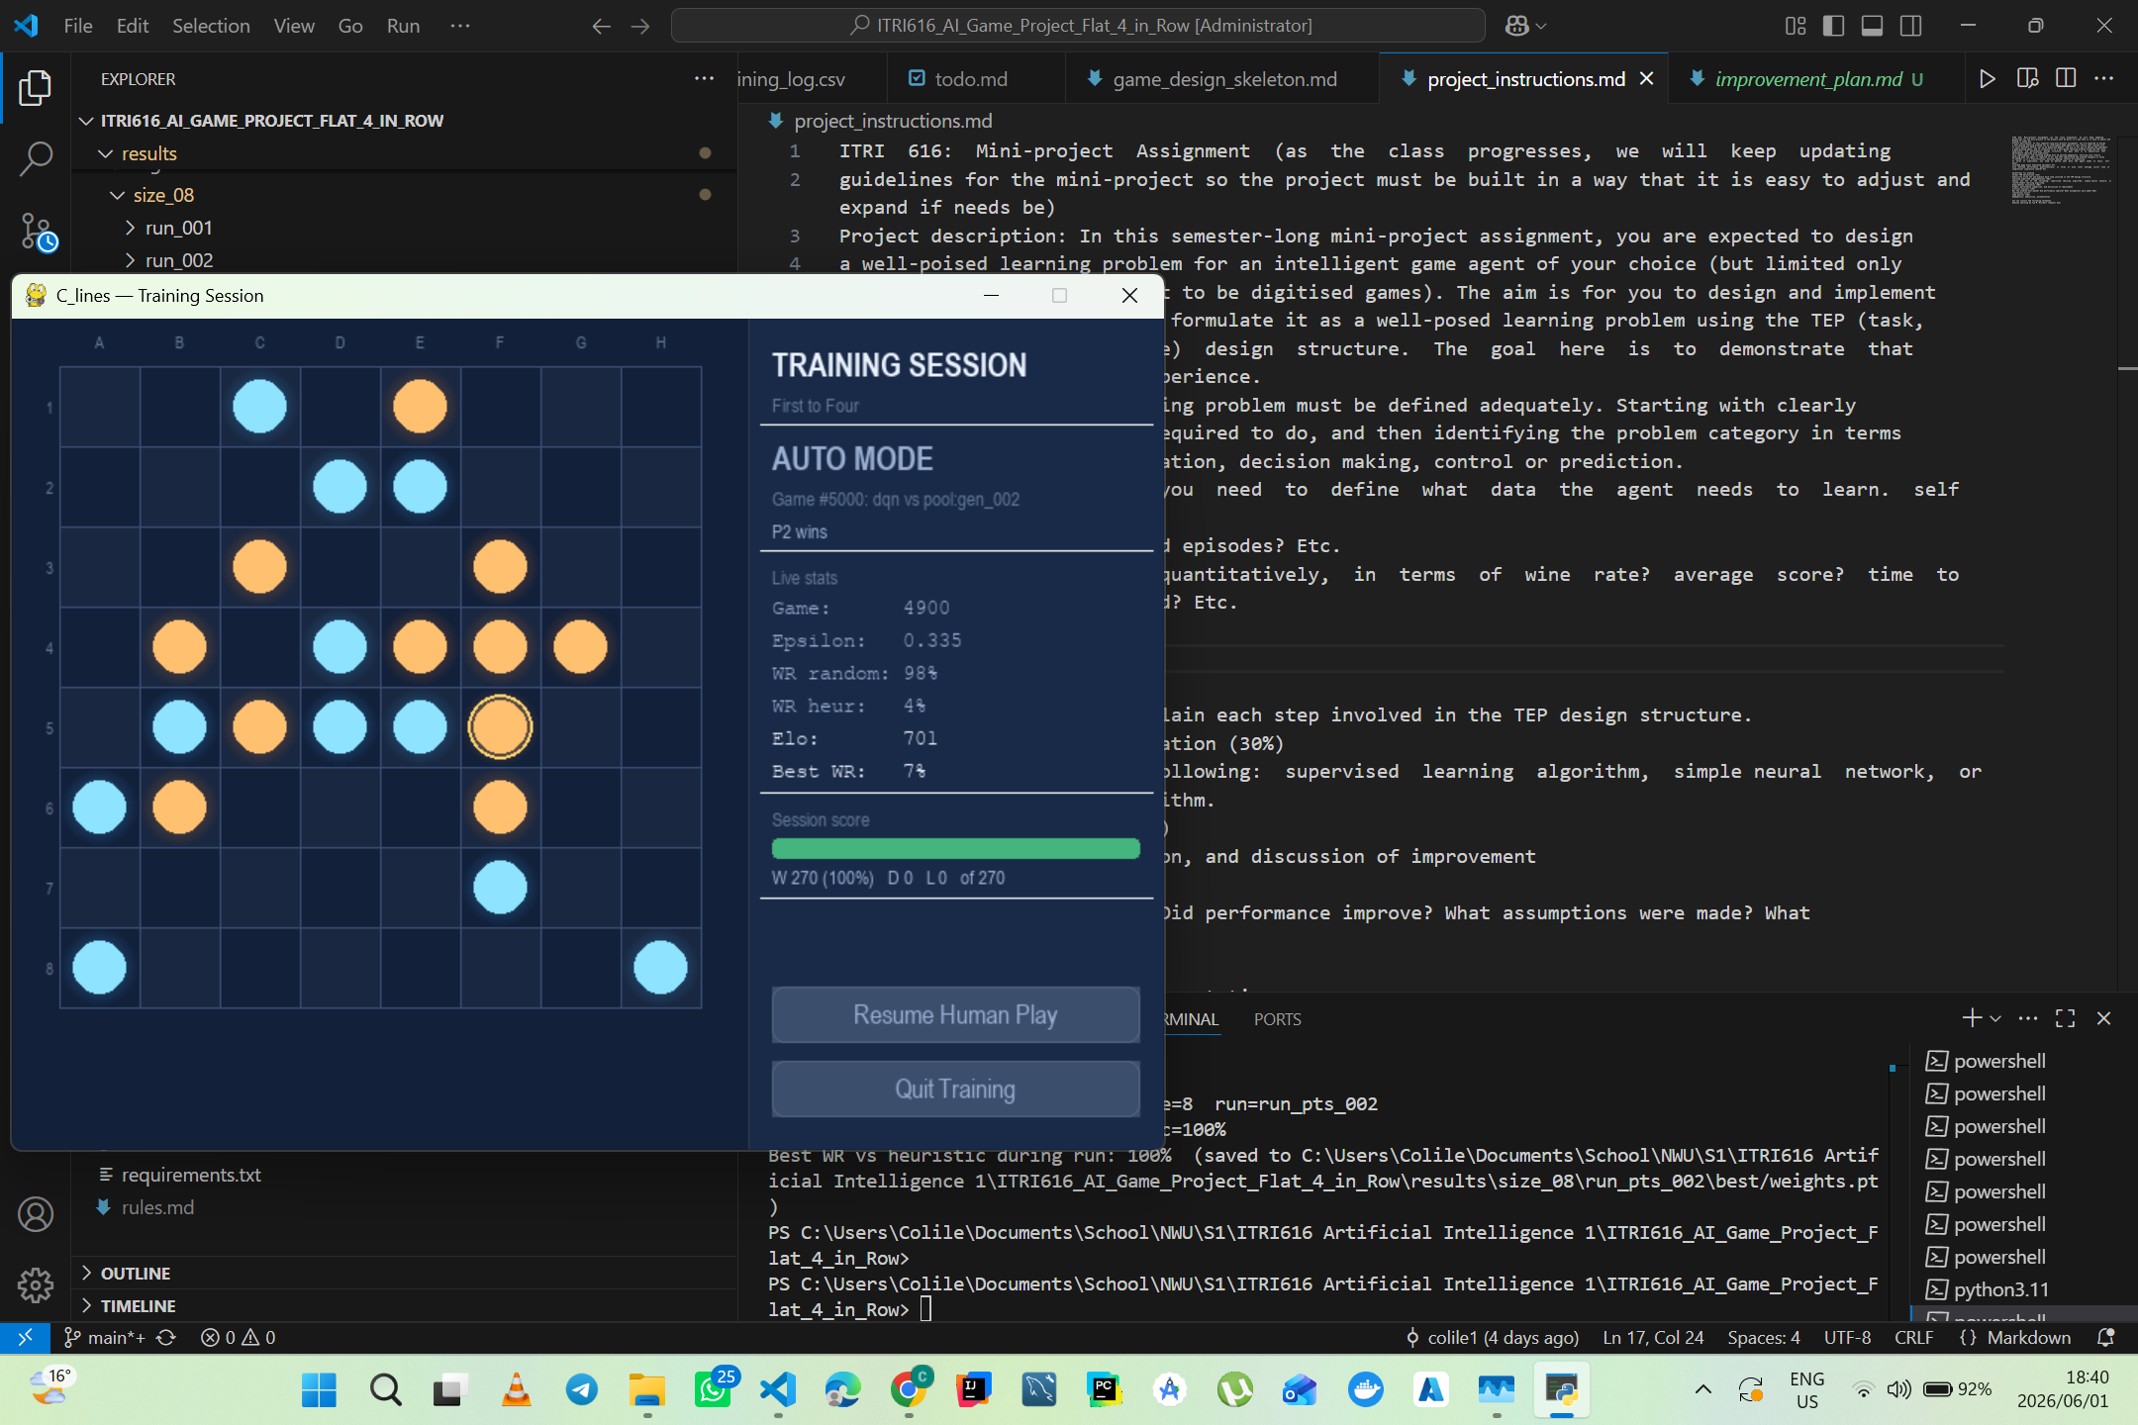

Contents
Contents 1
1. Introduction 1
2. Formal TEP Definitions 1
2.1 Task (T) 1
2.2 Experience (E) 1
2.3 Performance (P) 1
3. Learning-Algorithm Choices and Implementation 1
3.1 Algorithm selection 1
3.2 State representation 1
3.3 Network architecture 1
3.4 Training protocol 1
4. Experimental Evaluation Results 1
4.1 Setup 1
4.2 Headline result - performance improves with experience 1
4.3 The Elo curve 1
4.4 The decisive benchmark - beating a 4-ply search 1
4.5 Hypotheses and stability 1
5. Critical Analysis 1
5.1 Analysis of the learning model 1
5.2 Analysis of the learning method 1
5.3 Analysis of the results 1
5.4 Assumptions and limitations, and how to improve 1
6. Reflection on the Project as a Whole 1
References 1

1. Introduction
This report describes the design, implementation, and experimental evaluation of a learning agent for C_lines, an original two-player board game created for this project. C_lines is played on an 8x8 grid. Players alternate placing a single stone on any empty cell - placement is open, with no gravity and no column rule - and continue until the board is full at 64 placements. A player scores for every unbroken straight run of their own stones, horizontal, vertical, or diagonal, of length 3 to 8, with longer runs worth disproportionately more (length 3 = 0.25, 4 = 1.0, 5 = 2.0, 6 = 3.0, 7 = 4.0, 8 = 5.0). When the board fills, the player with the higher total line-score wins; a tie-break rule removes draws.
C_lines was designed specifically for this project, no published expert-play database, opening theory, or existing engine exists for it. This makes it a clean testbed for reinforcement learning: the agent has no source of supervised data and must learn entirely from playing against itself. This shows that agent's performance demonstrably improves with experience report shows based on four independent metrics.
The report contains the formal TEP definitions in (Section 2), the learning-algorithm choices and how they were implemented (Section 3), experimental evaluation results (Section 4), a critical analysis of the model, method, and results (Section 5), and a reflection on the project (Section 6). Installation and reproduction instructions are provided in the companion code-documentation deliverable. The source code can be found at https://github.com/Colile1/ITRI616_AI_Game_Project_C_Lines/tree/submission

2. Formal TEP Definitions
Following Mitchell's well-posed learning problem, the task is specified by three components a Task (T), an Experience (E), and a Performance measure (P). Each is given formally below.

2.1 Task (T)
Informal statement. Given the current state of a C_lines board, choose a cell on which to place a stone to maximise the agent's final score margin - its own line-score minus the opponent's when the board fills. Maximising the final margin is exactly equivalent to winning the points-until-full game.
Formal statement. The task is modelled as a finite-horizon Markov Decision Process MDP = (S, A, d, R, g, T_max), where S is the set of board configurations with the side-to-move, A is the set of 64 cell placements (masked to legal, empty cells), d is the deterministic transition function, R is the reward function, g is the discount factor, and T_max = 64 is the move horizon. The agent learns a policy pi : S -> A that maximises expected cumulative return.
Problem category. Sequential decision-making and control under perfect information with deterministic dynamics. It is not a classification problem - there is no fixed label per board - and not a prediction problem - the agent must act, and its actions determine the outcome. Identifying the category correctly matters because it dictates the algorithm family: control problems with delayed reward call for reinforcement learning rather than supervised learning. Every component of the MDP - state space, action space, transition function, and reward function - is implemented as a pure function with no hidden state.

2.2 Experience (E)
The agent learns from self-generated simulated episodes, there is no human-generated training data. Experience is produced in three layers that together form an automatically generated curriculum:
- Warm-up. The learner first plays a mix of a random opponent and a fixed tactical heuristic, seeding the replay memory with varied, legal positions.
- Self-play with a snapshot pool. The learner then plays frozen copies of its earlier selves, drawn from a pool biased toward recent (stronger) snapshots. As the learner improves, so do its opponents - the curriculum strengthens itself without manual tuning.
- Replay and augmentation. Each game produces a trajectory (s0, a0, r0, ..., sT), decomposed into single-step transitions (s_t, a_t, r_t, s_{t+1}, done, legal_mask) and stored in a fixed-capacity replay buffer (100,000 transitions, FIFO eviction). Every transition is reused for several gradient updates, and the board's eight-fold symmetry multiplies the effective data.
Feedback type and quantity. Feedback is indirect, delayed, and shaped: the terminal outcome arrives only at the last step of a 64-move game, while dense delta-score shaping makes the per-step signal informative enough for credit assignment. The reported run accumulates roughly 640,000 transitions over 10,000 games; the 100,000-capacity buffer rotates about six times across the run. A snapshot is frozen every 1,000 games and added to the opponent pool.

2.3 Performance (P)
Performance is measured quantitatively and logged every 100 games using four complementary metrics, so that the improvement claim does not rest on any single number that might saturate or be noisy:
Metric | What it captures | Justification
Win rate vs Random | Basic competence | A learning agent must dominate random play - a floor check.
Win rate vs Heuristic | Tactical competence | The heuristic blocks and builds lines; beating it requires real strategy.
Elo rating | Relative skill, one scalar | A smooth, comparable summary across the whole opponent set - the headline curve.
WR / score margin vs Alpha-Beta d4 | Strength vs principled search | The hardest, independent test - an opponent the agent never trains against.

Formal hypotheses. Four hypotheses were stated in advance and are evaluated in Section 4: (H1) the win rate against Random trends upward and ends above 0.75; (H2) the final win rate against the Heuristic is at least 0.90; (H3) final Elo exceeds starting Elo by at least 200 points; and (H4) the agent wins more than 50% of benchmark games against alpha-beta depth-4 by the end of training.

3. Learning-Algorithm Choices and Implementation

3.1 Algorithm selection
The agent is a Deep Q-Network (DQN) - value-based reinforcement learning. The network approximates the action-value function Q(s, a): the expected future score-margin of placing a stone on cell a in position s. At play time the agent selects the legal cell with the highest Q-value; during training it explores with an epsilon-greedy policy. DQN was selected after surveying the standard alternatives (tabular Q-learning, policy-gradient methods such as REINFORCE/PPO, AlphaZero-style MCTS with a neural network, neuroevolution, and value networks trained from self-play). The choice rests on four arguments:
- Fit to the problem. C_lines is a discrete-action, perfect-information, deterministic MDP - the textbook DQN setting. A placement's true value only emerges many moves later when the board fills, and Q-learning's bootstrapped temporal-difference target is purpose-built for exactly that delayed-credit-assignment problem.
- Evidence of learning. The action-value function yields a single Elo curve as the natural evidence of improvement - precisely what the brief grades.
- Snapshot economy. The network state is also the natural snapshot unit: each frozen copy doubles as a versioning artefact and a self-play opponent.
- Brief alignment. DQN is reinforcement learning with a neural-network value function - firmly within the allowed algorithm families - while a supervised classifier was ruled out because no labelled correct moves exist for an original game.

3.2 State representation
Each position is encoded as a 10-channel 8x8 tensor, always from the perspective of the player to move: own stones; opponent stones; empty cells; own open-3 threats; opponent open-3 threats; turn-progress; own open-4 threats; opponent open-4 threats; cells where the agent wins immediately; and cells where the opponent wins immediately. The three raw-occupancy channels give the network the board; the tactical channels hand it the features that matter for blocking and line-completion explicitly, which accelerates learning and lets the convolutional filters focus on combining threats rather than rediscovering them.

3.3 Network architecture
Four residual blocks at 64 channels with batch normalisation provide enough depth to compose multi-cell line patterns while training stably at a modest parameter budget; the skip connections keep gradients well-conditioned. Illegal cells are masked to -1e9 before the argmax, so the agent can never select an occupied cell.

3.4 Training protocol
Two-player (negamax) TD target. Because the stored next state s' is encoded from the opponent's perspective, the bootstrap term is subtracted, not added:
target = r - g * Q_target(s', argmax_a Q_online(s', a))
This is the correct value-propagation rule for a zero-sum, alternating-turn game: one player's value is the negative of the other's, so negating the bootstrap implements the negamax principle. It is the single most important correctness property of the implementation, and Section 5 analyses why.
- Double DQN. The online network selects the next action and the target network evaluates it, decoupling selection from evaluation and removing the value-overestimation bias of vanilla DQN.
- Loss. Huber (smooth-L1) loss, which is less sensitive to occasional large TD-error spikes than mean-squared error.
- Optimiser and schedule. Adam at an initial learning rate of 1e-3, with plateau-based decay that halves the rate whenever Elo improvement stalls. Four decays fired over the run: 1e-3 -> 5e-4 -> 2.5e-4 -> 1.25e-4.
- Exploration. Epsilon-greedy, decayed linearly from 1.0 to 0.05 over the first 7,000 games, then held at 0.05.
- Replay and stabilisers. 128-sample minibatches, four gradient steps per game, a target network synced periodically, and gradient clipping at norm 10. Sampling is weighted by transition source (human 5x, demonstration 10x, alpha-beta 2x, heuristic/self 1x).
- Symmetry augmentation. The D4 dihedral group (eight-fold) is applied at sample time, so each stored transition yields up to eight training examples - free, label-preserving data on a symmetric board.
- Reward design. Dense delta-score shaping - the per-move change in (own score - opponent score), scaled - plus a terminal +/-1 for the win or loss. Because the objective in points-until-full is to accumulate the larger score.
- Snapshotting. Every 1,000 games the model is frozen, evaluated, Elo-rated, registered as a selectable difficulty level (gen_001 ... gen_010), and admitted to the self-play pool.

4. Experimental Evaluation Results

4.1 Setup
One training run, run_pts_002: 8x8 board, points-until-full mode, 10,000 self-play games, on CPU only at a throughput of roughly 345-620 games per hour (about 29 hours total). Evaluation ran every 100 games (200 games versus Random and 100 versus the Heuristic), and the alpha-beta depth-4 benchmark ran periodically over 32 games per check. The training command was:
python -m src.training.train --games 10000 --size 8 --benchmark alphabeta_d4

4.2 Headline result - performance improves with experience
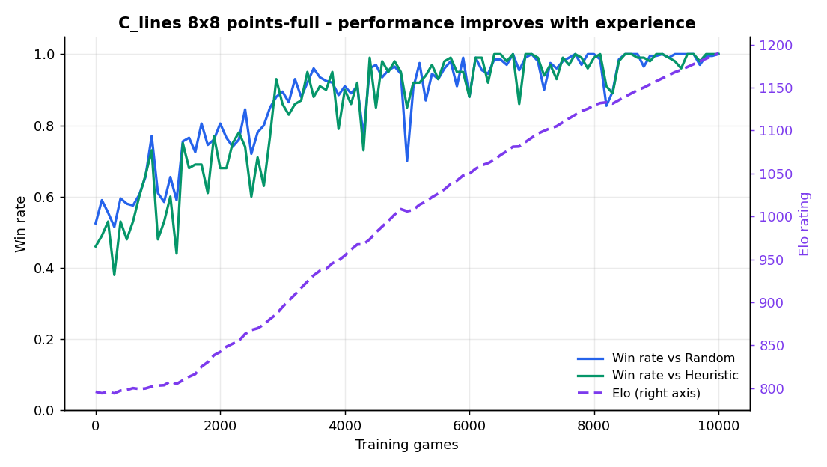
Figure 1 - Win rate vs Random and vs Heuristic (left axis) and Elo rating (right axis). All three rise together from random level to ceiling.
The snapshot progression below is taken directly from the model registry. Difficulty bands are assigned from measured win rates (>= 90% versus the Heuristic = Master), not from ordinal position, so the Easy-to-Master progression is genuine and observable.
Checkpoint | Games | Elo | WR vs Random | WR vs Heuristic
Start | 0 | 796 | 52.5% | 46%
gen_002 | 2,000 | 842 | 80.5% | 68%
gen_004 | 4,000 | 954 | 91% | 90%
gen_007 | 7,000 | 1,092 | 100% | 100%
gen_010 (final) | 10,000 | 1,190 | 100% | 100%

4.3 The Elo curve
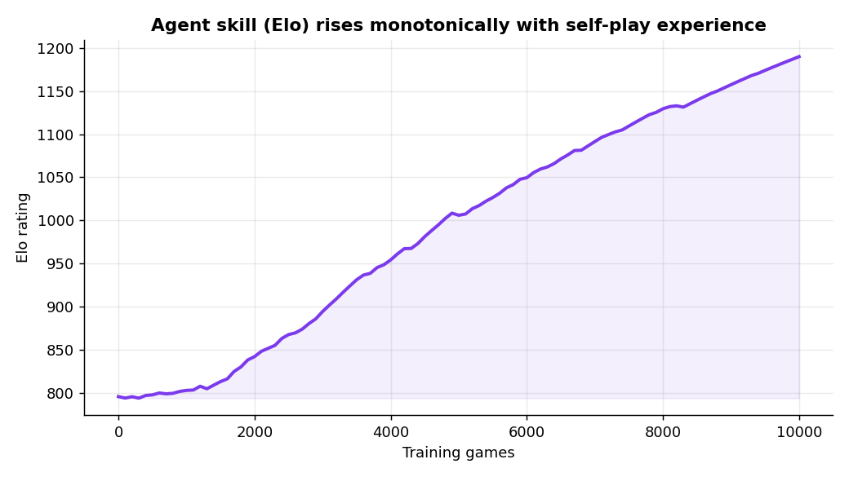
Figure 2 - Elo rating versus training games: a smooth, monotone increase from 796 to 1,190 (+394).
The Elo rating rose at every evaluation checkpoint across the entire run - from 796 at game 0 to 1,190 at game 9,999, a total gain of +394 points. It crosses the heuristic anchor (900) at about game 3,100 and the 1,000 milestone near game 5,000.

4.4 The decisive benchmark - beating a 4-ply search
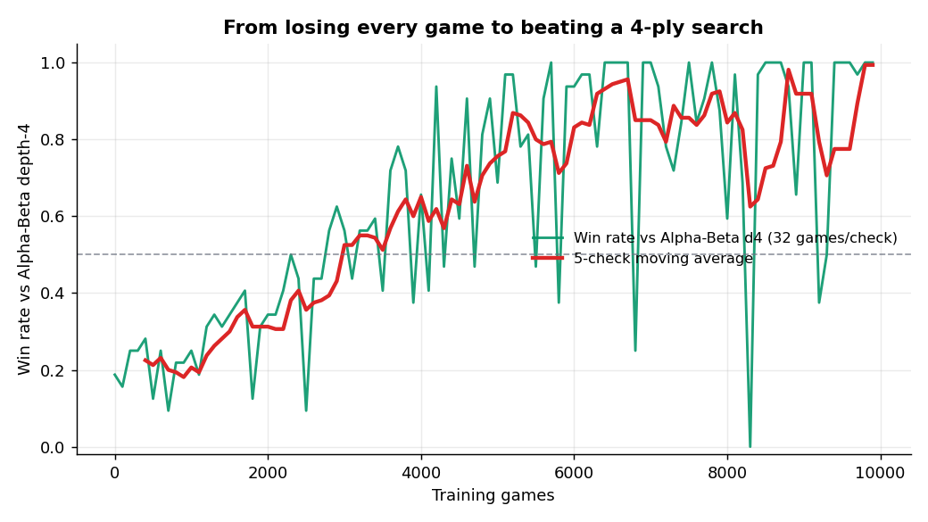
Figure 3 - Win rate vs alpha-beta depth-4 (32 games per check). The agent goes from ~19% (margin -0.83) to ~100% (margin +1.17).
The alpha-beta agent applies principled tree-search to depth 4, evaluating open lines and mobility; it is a strong, non-learning baseline that the agent never trains against. Early in training the agent wins about 19% of benchmark games and loses on score by an average margin of -0.83. By the end of the run it wins essentially 100% with the mean score margin reversed to about +1.17. Reversing both the win rate and the sign of the score margin against an independent adversarial search is far stronger evidence of genuine learning than merely beating random play.

4.5 Hypotheses and stability
All four hypotheses are confirmed: H1 (final WR vs Random 100% > 0.75), H2 (final WR vs Heuristic 100% >= 0.90), H3 (Elo +394 >= 200), and H4 (~100% versus alpha-beta depth-4 by end of run). The TD (Huber) loss stayed within the 0.000-0.020 range throughout the run with no spikes or divergence, consistent with the Double-DQN, Huber-loss, and target-network stabilisers. The plateau-based learning-rate scheduler triggered four decays, each time Elo improvement slowed, after which convergence resumed. The best-model checkpoint first reached 100% versus the Heuristic at game 6,400 and the final model matches it, confirming the end-of-run model is genuinely the strongest rather than an evaluation fluke.

5. Critical Analysis

5.1 Analysis of the learning model
The model has to solve two problems at once: recognise spatial line patterns and convert them into a comparison of one move against 63 alternatives. The residual convolutional network is well matched to the first. A line in C_lines is a local, translation-equivariant pattern - three, four, or more stones in a row look the same wherever they appear on the board - which is exactly what stacked 3x3 convolutions capture efficiently. Four residual blocks give a receptive field large enough to span an eight-cell line and to combine several partial threats, while the skip connections keep the optimisation well-conditioned so the network trains without the vanishing-gradient problems a plain deep stack would suffer at the same depth.
The 10-channel encoding is doing more analytical work than it first appears. By supplying open-3 and open-4 threats and immediate win/loss cells as explicit channels,.

5.2 Analysis of the learning method
Value-based DQN is the right method for this task.
The negamax target is what makes the value function coherent. In a self-play game the next state belongs to the opponent, so a value estimate read at s' is the opponent's expected return, not the agent's. Negating the bootstrap (target = r - g*Q(s',.)) propagates value with the correct sign through the alternating turns, so a position that is good for the opponent correctly lowers the agent's estimate.
Double DQN and Huber loss explain the absence of late-run collapse. Vanilla DQN's max operator systematically overestimates action values, and that bias tends to compound late in training when the network is confident - the classic failure mode is a strong mid-run agent that diverges. Decoupling action selection (online network) from evaluation (target network) removes most of that bias, and the Huber loss caps the gradient contribution of any single large TD error.
Reward shaping accelerates learning without changing the objective. The shaped signal is the per-move change in score margin, which sums over an episode to exactly the terminal margin. Because the shaping is a potential-like decomposition of the true objective rather than an auxiliary bonus, it densifies credit assignment - the agent gets a learning signal on every one of the 64 moves instead of only at the end - without introducing a competing goal.
Self-play plus symmetry augmentation supplies the curriculum and the data. The snapshot pool means the agent always faces an opponent near its own strength, so the gradient never vanishes from opponents that are too weak or too strong - the rising opponent strength is visible as the continued Elo climb after the win rates against the fixed baselines have already saturated at 100%.
The method's main limitation as a method is that it is one-step and value-only. One-step TD propagates the terminal outcome backwards one move per update.

5.3 Analysis of the results
The four metrics tell a consistent story, but each carries different information and the differences are themselves informative. The win rates against the fixed baselines (Figure 1) saturate: they reach 100% by game 7,000 and then carry no further signal, because a perfect score cannot distinguish a strong agent from an even stronger one. This saturation is exactly why Elo is the headline metric - it keeps resolving improvement after the baselines have been beaten, and its continued rise from 1,092 (game 7,000) to 1,190 (game 9,999) is evidence that self-play kept improving the agent even when the baseline win rates could no longer show it.
The per-snapshot win rates are also visibly noisy: gen_005 records 70% versus Random despite sitting on a rising Elo trajectory (1,006). This is not a regression but sampling noise from a 200-game estimate against a high-variance opponent, and it is the clearest practical argument for trusting the aggregated Elo curve over any single evaluation point. The benchmark result (Figure 3) is the strongest single piece of evidence precisely because alpha-beta depth-4 is independent of training: the agent cannot have memorised it, and open placement gives a 64-branch tree far too large to memorise in any case, so beating it implies genuine generalisation. The sign-flip of the mean score margin - from -0.83 to +1.17 - is more telling than the win rate alone, because it shows the agent does not merely win more often but wins by a margin.

5.4 Assumptions and limitations, and how to improve
The result rests on a small set of assumptions, each of which C_lines satisfies but which bound the claim: perfect information and deterministic a Markov state (the 10-channel encoding plus turn-progress is a sufficient statistic, since C_lines has no hidden state or history dependence); self-play sufficiency (playing past selves is a strong enough curriculum to reach expert play - beating an independent search supports this); and a fixed evaluation ceiling (the heuristic and depth-4 search do not adapt, so beating the benchmark means stronger than a 4-ply search, not optimal play). Within those bounds, the following improvements would most strengthen the work:
- Multi-seed validation. The reported result is one run. Repeating training across several random seeds and reporting the Elo curve as a mean with a confidence band would convert clearly-improves into a statistically defensible claim and quantify run-to-run variance, which a single smooth curve cannot.
- n-step returns. Replacing one-step TD with n-step (for example n = 3) would propagate end-of-game outcomes several moves per update, shortening the effective credit-assignment horizon and likely tightening the early-training Elo climb.
- Search at training time. The architecture is already a residual value network and an MCTS agent exists at inference. Adding a policy head and using Monte-Carlo Tree Search to generate improved training targets (an AlphaZero-style scheme) is a modest extension that would raise the ceiling beyond what a one-step value target can reach, and would let the agent surpass deeper search opponents.
- Prioritised replay and a stronger benchmark. Sampling transitions by TD-error magnitude would focus updates on positions the agent currently misjudges, and benchmarking against deeper alpha-beta (or the MCTS agent) would re-expose head-room once depth-4 is saturated.
- Larger compute budget. At CPU throughput a full run takes about a day, which limited the project to one configuration. A larger budget would support the multi-seed study above and allow the method to be tested at scale with the same learning rule.

6. Reflection on the Project as a Whole
Looking back over the project, three lessons stand out. The first is that in reinforcement learning, correctness of the objective matters more than complexity of the engineering. The infrastructure - a residual network, a replay buffer, self-play, snapshots - is standard once written; what determined success was getting the two-player value target right, so that the bootstrap reinforced the true outcome instead of working against it. A subtle error in what is being optimised is far more damaging, and far harder to detect, than any missing feature, because the code still runs and the loss still falls - it simply optimises the wrong thing.
The second is that measurement is part of the method, not an afterthought. Win rate against fixed opponents is noisy game-to-game and saturates once the agent is strong, which makes it hard to separate real progress from luck. Adopting Elo as the primary metric produced a single smooth curve that could be trusted to say whether a change helped, and it reshaped how the work was done: how-will-I-measure-this became a design question to answer before training, not after.

References
Mitchell, T. M. (1997). Machine Learning. McGraw-Hill. (TEP framework, Chapter 1.)
Mnih, V., Kavukcuoglu, K., Silver, D., et al. (2015). Human-level control through deep reinforcement learning. Nature, 518, 529-533. (DQN.)
Van Hasselt, H., Guez, A., & Silver, D. (2016). Deep reinforcement learning with Double Q-learning. AAAI, 30(1). (Double DQN.)
Huber, P. J. (1964). Robust estimation of a location parameter. Annals of Mathematical Statistics, 35(1), 73-101. (Huber / smooth-L1 loss.)
Sutton, R. S., & Barto, A. G. (2018). Reinforcement Learning: An Introduction (2nd ed.). MIT Press. (Replay, epsilon-greedy, TD learning.)
Silver, D., Huang, A., Maddison, C. J., et al. (2016). Mastering the game of Go with deep neural networks and tree search. Nature, 529, 484-489. (Self-play and residual-network inspiration.)
He, K., Zhang, X., Ren, S., & Sun, J. (2016). Deep residual learning for image recognition. CVPR, 770-778. (Residual architecture.)

